Michael Weaver, Caleb Miller, Mathew Paschall

CST – 235

Brandon Bass

12/10/17

**CLC 5**

GitHub Link: <https://github.com/battousairurik/CST-235>

**Assignment Approach**

Michael

1. The Glassfish 5 directory installs easily enough and the path variables set as well, though at current Glassfish 5 does not interact with JDK 9, therefor getting it to run is not possible unless the active version of JAVA is reduced to JAVA 8 or less.

* Glassfish is a flexible, multi-purpose Application Server
* It is an interactive web front for java programs
* There is a Glassfish open source edition valuable to small businesses
* Free upfront or pay for increased usability
* Glassfish is Java EE certified
* Ease of use due to command line activation

After reviewing Glassfish, I have concluded that it is less appealing than its competitors such as WildFly, especially during development. With WildFly the instillation process was painless and there were no path variables that needed to be set. Even the download was automated and efficient. Comparatively, Glassfish does not even run with Java 9, which means that many devices will not even be able to run a Glassfish server (myself included) so using WildFly is easier and makes more sense.

1. I did manage to find the sample application in the startup guide, hello.war and then downloaded to a local directory. Because I cannot use the asadmin commands for glassfish I imported the war file to JavaEE to convert it into a project that can be deployed from there. After attempting such, the jsp file will not launch and I am given an error. Currently, I cannot determine why the file will not compile correctly.

* Note: There is no code for this CLC since it is all installing a server and running an example application.

Caleb

1. May believe my versioning is all messed up. Currently running JDK 9, and it would not recognize GlashFish 5 and when running through GlassFish 4, I get a 500 error. Either way either version was easy to install and attempt to run.
   * Piggy-backing off Michael; GlassFish is an open-source application server started by Sun Microsystems for JavaEE.
   * JavaEE Certified
   * Both paid and free versions
   * Built on a modular kernel powered by OSGi, and runs straight on top of the Apache Felix implementation.

Conclusion is that understanding that it is open-source I understand why it isn’t compatible with JDK 9, but because of that its always good to have the most up to date software so maybe a paid version would be more suitable if this were implemented for a business.

1. Experiencing the same issue as Michael. See here.

Mathew

**List of Classes, Methods, Variables, etc.**

Michael’s Attempt

Glassfish directory, path environment variables set to execute, hello.war, and hello sample application extracted as a jsp application

Caleb’s Attempt

Incomplete, received 500 HTTP ERROR.

Mathew’s Attempt

**Michael’s Screenshots**

CMD asadmin check

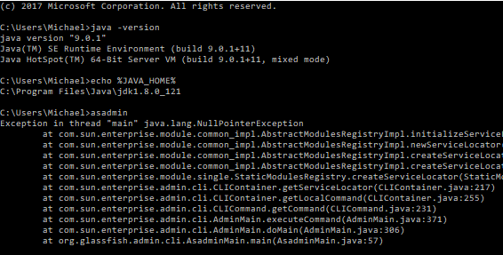

Glassfish directory

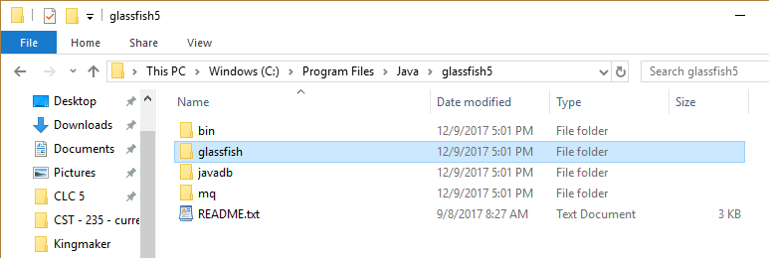

Sample Application Instillation

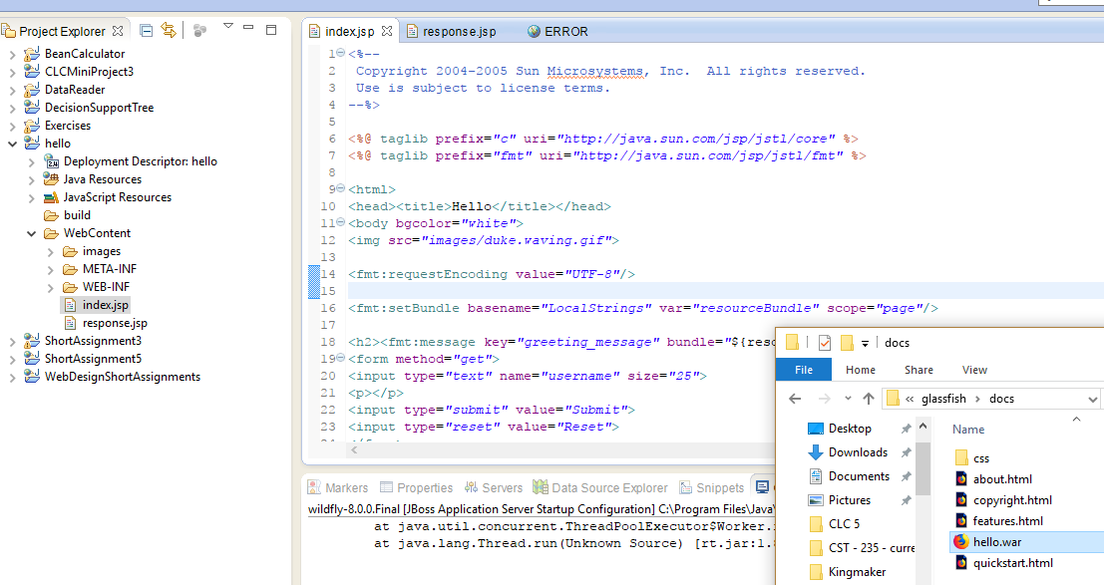

Deployment

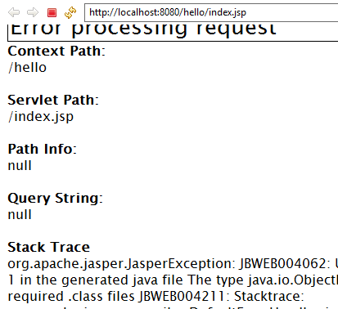

**Caleb’s Screenshots**

**(GlassFish 5)**

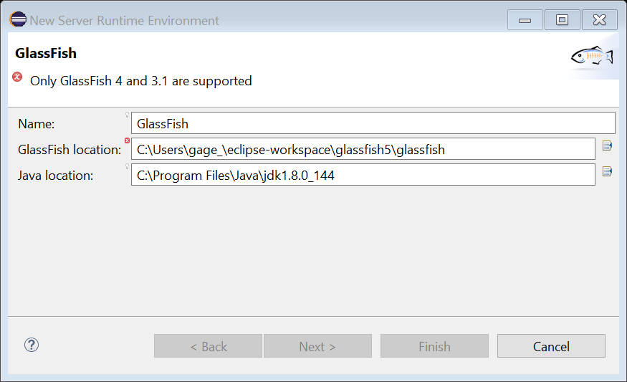

**(GlassFish 4)**

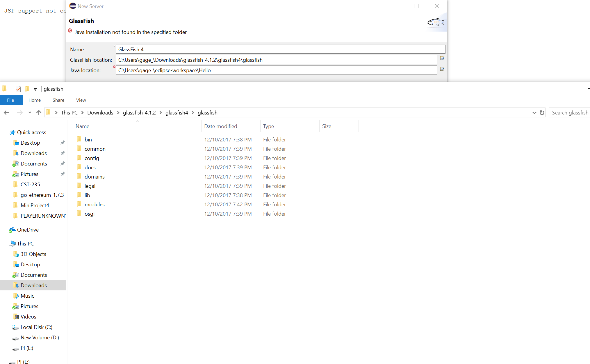

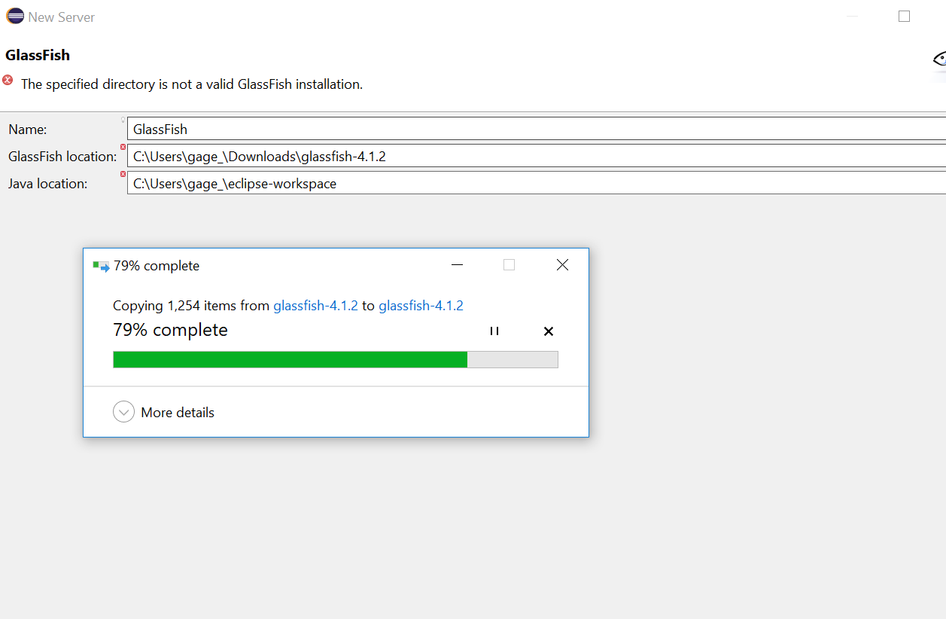

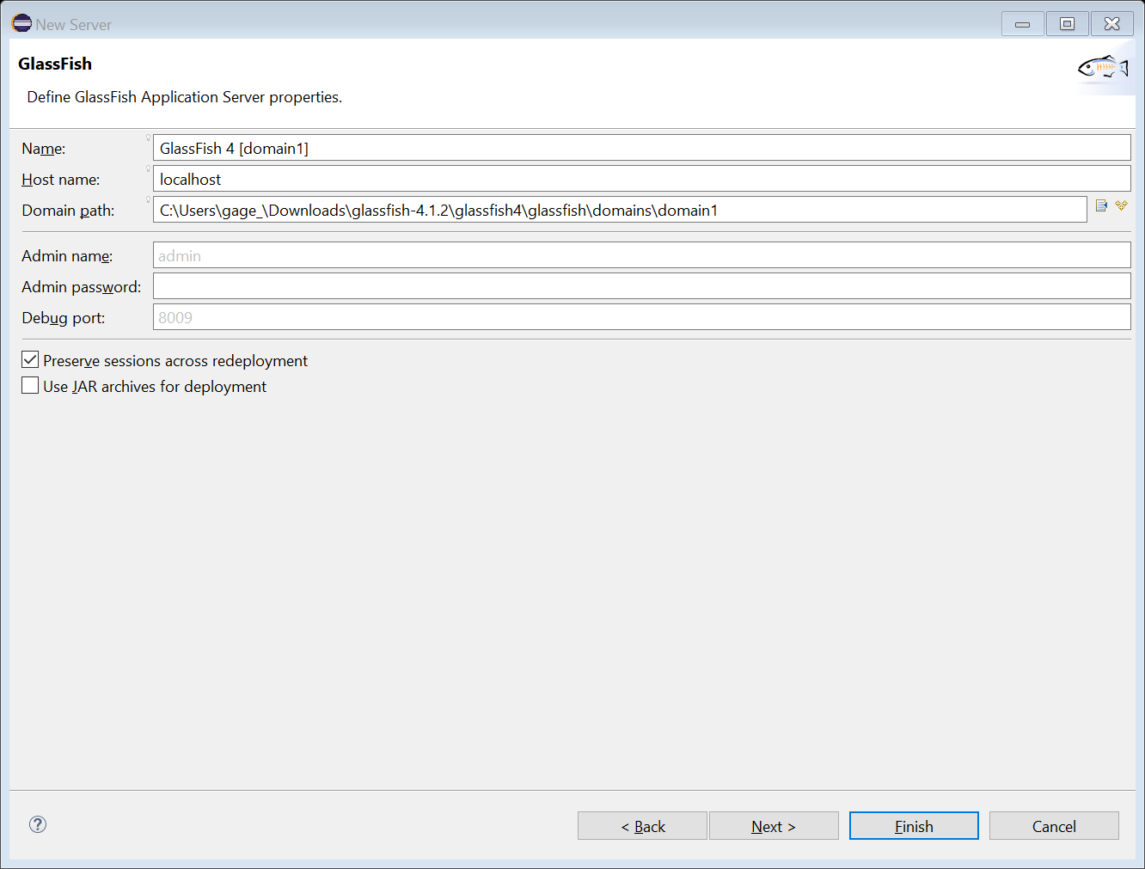

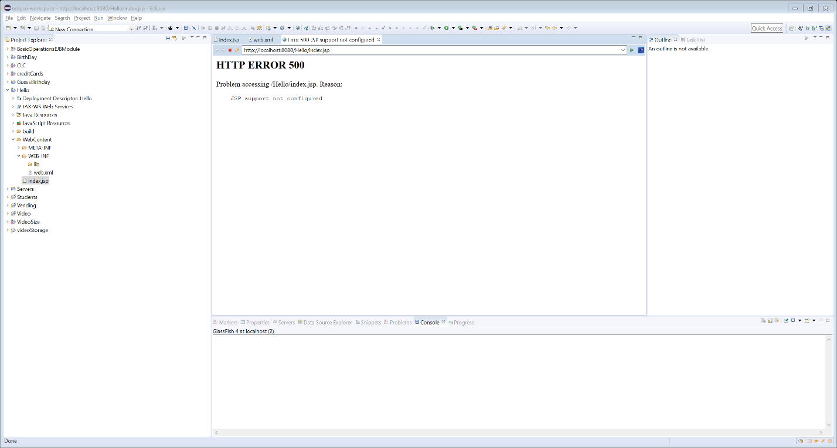

**Mathew’s Screenshots**

start